HTML AND CSS EXAM –ALL THE BEST

User Registration and Authentication

Description:

Design and develop static web pages for user registration and authentication using only HTML and CSS.

Question:

Create a registration form and a login form using HTML. Include fields for username, email address, and password in the registration form, and fields for username/email and password in the login form. Implement client-side validation for the registration form to ensure all fields are filled out and the email address is in a valid format. Style both forms using CSS to create a visually appealing user interface.

**Code:**

**Html:**

<!DOCTYPE html>

<html lang="en">

<head>

  <meta charset="UTF-8" />

  <meta name="viewport" content="width=device-width, initial-scale=1.0" />

  <title>User Registration and Login </title>

  <link rel="stylesheet" href="login.css" />

</head>

<body>

  <div class="total-page">

    <div class="form-container">

      <h2>Registration Form</h2>

      <form class="form-details">

        <div class="form-fields">

          <label for="name">Name</label>

          <input type="text" placeholder="Enter the name here!" id="name" name="name" required />

        </div>

        <div class="form-fields">

          <label for="email">Email</label>

          <input type="email" placeholder="Enter the email here!" required id="email" name="email" />

        </div>

        <div class="form-fields">

          <label for="password">Password</label>

          <input type="password" placeholder="Enter the password here!" required id="Password" name="password" />

        </div>

        <div class="form-fields reg">

          <input type="submit" value="Register" />

        </div>

      </form>

    </div>

    <div class="login-container">

      <h2>Login form</h2>

      <form class="login-form">

        <div class="login-name">

          <label for="name">Name</label>

          <input type="text" placeholder="Enter the name here!" id="name" name="name" required />

        </div>

        <div class="login-name">

          <label for="password">Password</label>

          <input type="password" placeholder="Enter the password here!" id="password" name="Password" required />

        </div>

        <div class="login-name">

          <input class="button" type="submit" value="login" />

        </div>

      </form>

    </div>

  </div>

</body>

</html>

**Css:**

* {

    margin: 0px;

    padding: 0px;

    box-sizing: border-box;

  }

  body {

    background-color: #21c9ad;

    margin-right: 60px;

  }

  .total-page{

    display: flex;

   align-items: center;

   justify-content: center;

    height: 100vh;

    margin-right: 250px;

  width: 100%;

  }

  .form-container {

   padding: 20px;

   width: 100%;

   border: 1px;

   border-radius: 10px;

   margin-left: 20px;

}

  .form-container h2 {

    margin: 15px;

    color: #f12077;

  }

  .form-details {

    width: 50%;

    padding: 20px;

    border: 2px solid #f9f5f5;

    background-color: #fff;

    border-radius: 10px;

    box-shadow: 0 0 6px rgba(0, 0, 0, 0.5);

  }

  .form-fields input {

    width: 100%;

    padding: 10px;

    margin-bottom: 10px;

    border-radius: 10px;

    margin-top: 10px;

  }

  .form-fields label {

    font-family:'Courier New', Courier, monospace;

    font-size: 20px;

  }

  .form-fields input:hover {

    border: 2px solid rgb(255, 43, 209);

  }

  .form-fields input::placeholder {

    padding-left: 10px;

    font-family:'Lucida Sans', 'Lucida Sans Regular', 'Lucida Grande', 'Lucida Sans Unicode', Geneva, Verdana, sans-serif;

    font-size: 15px;

    color: rgb(104, 101, 103);

  }

  .reg input {

    border: none;

    font-size: 20px;

    font-family: "Segoe UI", Tahoma, Geneva, Verdana, sans-serif;

    background-color: lightblue;

  }

  .reg input:hover {

    background-color:lightsalmon;

    border: 2px solid#555;

    color: #ffff;

  }

  login/

  .login-container {

    padding: 50px;

    width: 100%;

    border: 1px;

    border-radius: 10px;

    margin:auto;

 }

  .login-container h2 {

    margin: 10px;

    color:#f12077;

    font-family: "Trebuchet MS", "Lucida Sans Unicode", "Lucida Grande",

      "Lucida Sans", Arial, sans-serif;

  }

  .login-form {

    border: 2px solid #fff;

    width: 100%;

    background-color: #fff;

    border-radius: 10px;

    padding: 20px;

    box-shadow: 0 0 6px rgba(0, 0, 0, 0.5);

    margin-right: 300px;

  }

  .login-name input {

    width: 100%;

    padding: 10px;

    margin-bottom: 10px;

    border-radius: 10px;

    margin-top: 10px;

  }

  .login-name input::placeholder {

    padding-left: 10px;

    font-family: "Lucida Sans", "Lucida Sans Regular", "Lucida Grande",

      "Lucida Sans Unicode", Geneva, Verdana, sans-serif;

    font-size: 15px;

    color: rgb(10, 103, 195);

  }

  .login-name input:hover {

    border: 2px solid rgb(180, 36, 36);

  }

  .login-name label {

    font-family: "Gill Sans", "Gill Sans MT", Calibri, "Trebuchet MS", sans-serif;

    font-size: 20px;

  }

  .button {

    border: none;

    font-size: 20px;

    font-family: "Segoe UI", Tahoma, Geneva, Verdana, sans-serif;

    background-color: lightsalmon;

  }

  .button:hover {

    background-color:lightseagreen;

    border: 2px solid#555;

    color: #ffff;

  }

**Output:**

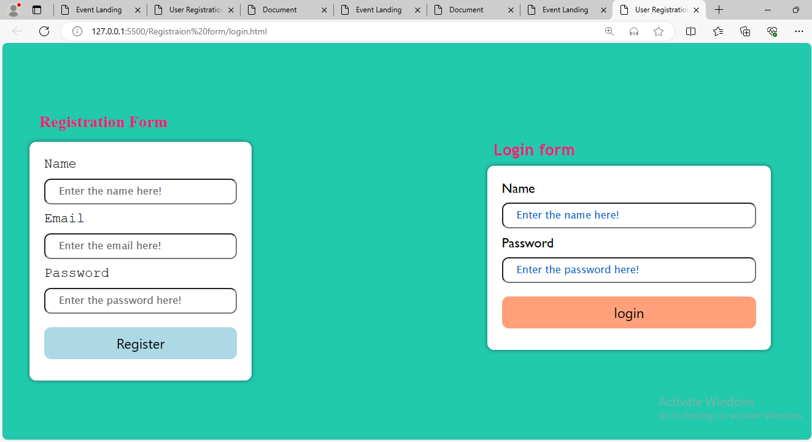

Use Case 11: Product Showcase Website

Description:

Develop a static website showcasing a collection of products. Each product should have a title, description, image, and price displayed on the website. Implement a responsive layout using HTML and CSS to ensure the website looks good on various devices. Include navigation links or buttons to allow users to browse through different product categories.

**Code:**

**Html:**

<!DOCTYPE html>

<html lang="en">

<head>

    <meta charset="UTF-8">

    <meta name="viewport" content="width=device-width, initial-scale=1.0">

    <title> Product</title>

    <link rel="stylesheet" href="product.css">

</head>

<body>

    <div class="total-page">

        <div class="myntra">

            <div class="mytra-product">

                <div class="products"><img src="images/download (1).png" alt="image" width="88px" height="88px"></div>

            </div>

            <div class="Contact">

                <a href="">Home</a>

                <a href="">products</a>

                <a href="">About</a>

                <a href="">Contact Us</a>

            </div>

        </div>

    </div>

    <div class="info">

        <div class="categories">

            <a href="">Mens wear</a>

            <a href="">womens wear</a>

            <a href="">watches</a>

            <a href="">foot wear</a>

            <a href="">kids wear</a>

        </div>

    </div>

    <div class="sale">

        <div class="sale-offer">

            <div class="season">

                <h1>Season sale</h1>

                <p>Lorem ipsum dolor sit amet consectetur adipisicing elit. A ullam, reiciendis mollitia, nihil, atque

                    quod itaque cum repellat assumenda neque vel accusamus. Eligendi cumque corrupti repellendus

                    dolorem, quas odit sunt.</p>

            </div>

            <div class="image">

                <img src="images/sale.jpeg" alt="image">

            </div>

        </div>

    </div>

    <div class="sale doc">

        <div class="sale-offer">

            <div class="image">

                <img src="images/download.jpeg" alt="image">

            </div>

            <div class="season">

                <h1>Season sale</h1>

                <p>Lorem ipsum dolor sit amet consectetur adipisicing elit. A ullam, reiciendis mollitia, nihil, atque

                    quod itaque cum repellat assumenda neque vel accusamus. Eligendi cumque corrupti repellendus

                    dolorem, quas odit sunt.</p>

            </div>

        </div>

    </div>

    <div class="mens-wear ">

        <div class="suites">

            <div class="head">

                <h2>Mens Wear</h2>

            </div>

            <div class="mens-dress ">

                <div class="mens">

                    <img src="images/mens wear6.jpeg" alt="Image" />

                    <div class="about-area">

                        <h3 class="title-area">wedding dress</h3>

                        <p class="about-card">$250</p>

                    </div>

                    <button>Add to cart</button>

                </div>

                <div class="mens">

                    <img src="images/images (1).jpeg" alt="Image" />

                    <div class="about-area">

                        <h3 class="title-area"> t-shirt</h3>

                        <p class="about-card">$345</p>

                    </div>

                    <button>Add to cart</button>

                </div>

                <div class="mens">

                    <img src="images/images.jpeg" alt="Image" />

                    <div class="about-area">

                        <h3 class="title-area"> gym wear</h3>

                        <p class="about-card">$450</p>

                    </div>

                    <button>Add to cart</button>

                </div>

                <div class="mens">

                    <img src="images/mens wear.jpeg" alt="Image" />

                    <div class="about-area">

                        <h3 class="title-area"> shirt</h3>

                        <p class="about-card">$450</p>

                    </div>

                    <button>Add to cart</button>

                </div>

            </div>

        </div>

    </div>

    <div class="mens-wear womens-wear">

        <div class="suites">

            <div class="head top">

                <h2>Womens Wear</h2>

            </div>

            <div class="mens-dress ">

                <div class="mens">

                    <img src="images/download (1).jpeg" alt="Image" />

                    <div class="about-area">

                        <h3 class="title-area"> kurtha</h3>

                        <p class="about-card">$250</p>

                    </div>

                    <button>Add to cart</button>

                </div>

                <div class="mens">

                    <img src="images/images (2) myntra..jpeg" alt="Image" />

                    <div class="about-area">

                        <h3 class="title-area"> long tops</h3>

                        <p class="about-card">$345</p>

                    </div>

                    <button>Add to cart</button>

                </div>

                <div class="mens">

                    <img src="images/images (2)myntra.jpeg" alt="Image" />

                    <div class="about-area">

                        <h3 class="title-area">western wear</h3>

                        <p class="about-card">$450</p>

                    </div>

                    <button>Add to cart</button>

                </div>

                <div class="mens">

                    <img src="images/download (2).jpeg" alt="Image" />

                    <div class="about-area">

                        <h3 class="title-area">Tops</h3>

                        <p class="about-card">$450</p>

                    </div>

                    <button>Add to cart</button>

                </div>

            </div>

        </div>

    </div>

    <div class="mens-wear watches">

        <div class="suites">

            <div class="head titan">

                <h2>Watches</h2>

            </div>

            <div class="mens-dress ">

                <div class="mens">

                    <img src="images/download  myntra.jpeg" alt="Image" />

                    <div class="about-area">

                        <h3 class="title-area">women rose</h3>

                        <p class="about-card">$1500</p>

                    </div>

                    <button>Add to cart</button>

                </div>

                <div class="mens">

                    <img src="images/download (3)watch.jpeg" alt="Image" />

                    <div class="about-area">

                        <h3 class="title-area"> Daneil</h3>

                        <p class="about-card">$3453</p>

                    </div>

                    <button>Add to cart</button>

                </div>

                <div class="mens">

                    <img src="images/images (2)  watches 2.jpeg" alt="Image" />

                    <div class="about-area">

                        <h3 class="title-area"> Rose Gold</h3>

                        <p class="about-card">$4502</p>

                    </div>

                    <button>Add to cart</button>

                </div>

                <div class="mens">

                    <img src="images/images (2) watches 3.jpeg" alt="Image" />

                    <div class="about-area">

                        <h3 class="title-area">Smart watch</h3>

                        <p class="about-card">$4500</p>

                    </div>

                    <button>Add to cart</button>

                </div>

            </div>

        </div>

    </div>

    <div class="mens-wear ">

        <div class="suites foot">

            <div class="head wear">

                <h2>Foot Wear</h2>

            </div>

            <div class="mens-dress ">

                <div class="mens">

                    <img src="images/shoe1.jpeg" alt="Image" />

                    <div class="about-area">

                        <h3 class="title-area">sport shoes</h3>

                        <p class="about-card">$550</p>

                    </div>

                    <button>Add to cart</button>

                </div>

                <div class="mens">

                    <img src="images/footwear.jpeg" alt="Image" />

                    <div class="about-area">

                        <h3 class="title-area">Soild Sandels</h3>

                        <p class="about-card">$450</p>

                    </div>

                    <button>Add to cart</button>

                </div>

                <div class="mens">

                    <img src="images/heels.jpeg" alt="Image" />

                    <div class="about-area">

                        <h3 class="title-area">Heels</h3>

                        <p class="about-card">$600</p>

                    </div>

                    <button>Add to cart</button>

                </div>

                <div class="mens">

                    <img src="images/lofers.jpeg" alt="Image" />

                    <div class="about-area">

                        <h3 class="title-area">Lofers</h3>

                        <p class="about-card">$750</p>

                    </div>

                    <button>Add to cart</button>

                </div>

            </div>

        </div>

    </div>

    <div class="mens-wear ">

        <div class="suites kids">

            <div class="head trends">

                <h2>Kids Wear</h2>

            </div>

            <div class="mens-dress ">

                <div class="mens">

                    <img src="images/kid5.jpeg" alt="Image" />

                    <div class="about-area">

                        <h3 class="title-area">Night wear</h3>

                        <p class="about-card">$200</p>

                    </div>

                    <button>Add to cart</button>

                </div>

                <div class="mens">

                    <img src="images/kid7.jpeg" alt="Image" />

                    <div class="about-area">

                        <h3 class="title-area">Princess dress</h3>

                        <p class="about-card">$300</p>

                    </div>

                    <button>Add to cart</button>

                </div>

                <div class="mens">

                    <img src="images/kid3.jpeg" alt="Image" />

                    <div class="about-area">

                        <h3 class="title-area">Traditional outfits</h3>

                        <p class="about-card">$100</p>

                    </div>

                    <button>Add to cart</button>

                </div>

                <div class="mens">

                    <img src="images/kid4.jpeg" alt="Image" />

                    <div class="about-area">

                        <h3 class="title-area">Forks</h3>

                        <p class="about-card">$150</p>

                    </div>

                    <button>Add to cart</button>

                </div>

            </div>

        </div>

    </div>

    <div class="total-form">

        <div class="form">

            <form class="feilds">

                <div class="name">

                    <label for="name">Name</label>

                    <input type="text" placeholder="type here" id="name" name="name">

                </div>

                <div class="name">

                    <label for="email">Email</label>

                    <input type="email" placeholder="type here" id="email" name="email">

                </div>

                <div class="message">

                    <label for="message">Message</label>

                    <textarea name="message" id="message"></textarea>

                </div>

                <div class="submit">

                <input type="submit" value="Contact me">

            </div>

            </form>

        </div>

    </div>

    <footer>

        <div class="base">

            <div class="right">

                <h4>@copy rights 2024 by:Sharvani reddy</h4>

            </div>

        </div>

    </footer>

</body>

</html>

**Css:**

*{

    margin: 0px;

    padding: 0px;

    box-sizing:border-box;

}

.total-page{

    background: radial-gradient(#fff,lightpink);

    height: 100%;

}

.myntra{

    display: flex;

    justify-content: space-between;

    align-items: center;

    padding: 10px 20px;

}

.products img{

    border-radius: 50%;

    box-shadow: 0 0 5px rgba(0,0, 0, 0.5);

}

.Contact a{

    margin-left: 20px;

    margin-right: 20px;

    text-decoration: none;

    font-size: 20px;

    font-weight: bold;

    font-family: 'Segoe UI', Tahoma, Geneva, Verdana, sans-serif;

}

.categories a{

    text-decoration: none;

    margin-left: 20px;

    margin-right: 20px;

    text-decoration: none;

    font-size: 30px;

    font-weight: bold;

    font-family: 'Segoe UI', Tahoma, Geneva, Verdana, sans-serif;

    margin-top: 80px;

    margin-bottom: 80px;

    padding: 20px;

    border: 1px solid #fff;

    background-color: aquamarine;

    border-radius: 20px;

    color: rgb(241, 87, 151);

    transition: transform 0.6secs;

}

.info{

    background: radial-gradient(#fff,rgb(100, 189, 147));

    height: 100%;

}

.categories{

    display:flex;

    align-items: center;

    justify-content: center;

}

.categories a:hover{

    transform:translateY(-10px);

}

.sale{

    background:linear-gradient(90deg,pink,lightgreen)

}

.sale-offer{

    display: flex;

}

.season{

    margin-top: 40px;

    padding: 15px;

    margin-left: 20px;

}

.season h1{

    font-size:40px;

    font-weight: bold;

    font-family: 'Franklin Gothic Medium', 'Arial Narrow', Arial, sans-serif;

}

.season p{

width: 450px;

line-height: 1.5;

font-size: 30px;

}

.image img{

    margin-left: 120px;

    width: 500px;

    height: 400px;

    border-radius: 15px;

    margin-top: 40px;

    margin-bottom: 40px;

}

.doc{

    background:linear-gradient(90deg,rgb(19, 201, 176),rgb(172, 126, 67))

}

.mens-wear{

    background:linear-gradient(90deg,rgb(240, 79, 100),rgb(56, 241, 217),rgb(233, 87, 172));

    height: 100%;

    position: relative;

}

.mens-dress{

    display: grid;

    grid-template-columns: repeat(4,1fr);

    grid-gap: 10px;

    padding: 20px;

    justify-content: center;

    height: 100%;

}

.mens {

    margin-top: 60px;

    margin-left: 20px;

    border: 1px solid #fff;

    border-radius: 20px;

    box-shadow: 0px 4px 8px rgba(0,0, 0, 0.1);

    transition: transform 0.3s;

}

.mens img{

    width: 100%;

    height: 300px;

    object-fit: cover;

    border-radius: 20px;

    cursor: pointer;

}

.about-area{

    padding: 30px;

}

.title-area{

    font-size: 30px;

    font-family: 'Times New Roman', Times, serif;

    font-weight: bolder;

    margin-bottom: 5px;

}

.mens:hover{

    transform: translateY(-20px);

}

.head h2{

    font-size: 30px;

    font-family: 'Franklin Gothic Medium', 'Arial Narrow', Arial, sans-serif;

    font-weight: bolder;

   border-bottom: 4px solid rgb(5, 95, 83);

    margin-left: 30px;

    padding-left: 20px;

    padding-top: 50px;

    width: 200px;

}

.womens-wear{

    background: linear-gradient(90deg ,rgb(128, 54, 67),rgb(72, 122, 43));

    height: 100%;

}

.top h2{

font-size: 25px;

}

.watches{

    background: linear-gradient(90deg,rgb(97, 173, 34),rgb(124, 209, 205),rgb(49, 211, 162));

    height: 100;

}

.titan{

    font-size: 20p;

}

.foot{

    background: linear-gradient(90deg,rgb(226, 64, 91),rgb(158, 204, 49),rgb(162, 219, 200));

    height: 100%;

}

.wear{

    font-size: 20px;

}

.kids{

    background: linear-gradient(90deg,rgb(235, 137, 9),rgb(55, 93, 196),rgb(137, 217, 228));

    height: 100%;

}

.trends{

    font-size: 20px;

}

button{

    border: none;

    padding: 20px;

    margin-left: 80px;

    margin-top: 20px;

    margin-bottom: 20px;

    border-radius: 10px;

}

button:hover{

    background-color: blue;

}

.total-form{

    display: flex;

    justify-content: center;

    align-items: center;

    height: 100vh;

    background: linear-gradient(90deg,pink,rgb(124, 236, 124));

}

.feilds{

    border: 2px solid black;

    padding: 80px;

    border-radius: 10px;

}

.name input{

    border: 1px solid wheat;

    border-radius: 10px;

    padding: 10px;

    margin: 5px;

    width: 100%;

}

.message textarea{

    border: 1px solid wheat;

    border-radius: 10px;

    padding: 20px;

    width: 100%;

}

.submit input{

    width: 100%;

    padding: 10px;

    border-radius: 20px;

    margin-top: 10px;

    cursor: pointer;

}

footer{

    background-color: #555;

    height: 50px;

    padding: 15px;

}

.right h4{

    margin-top: 10px;

    text-align: center;

    margin-bottom: 10px;

    color: aliceblue;

}

**Output:**

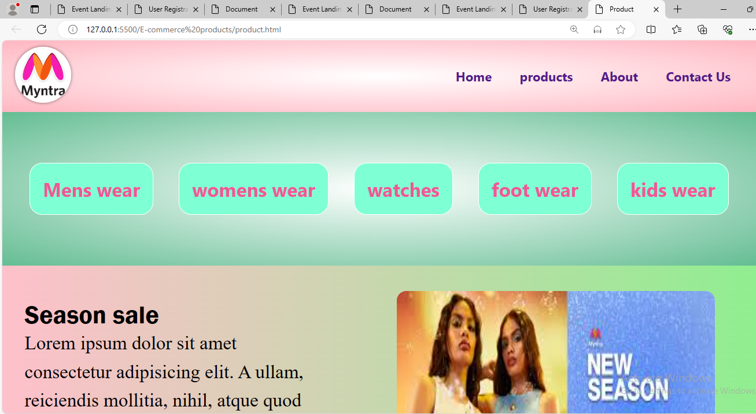

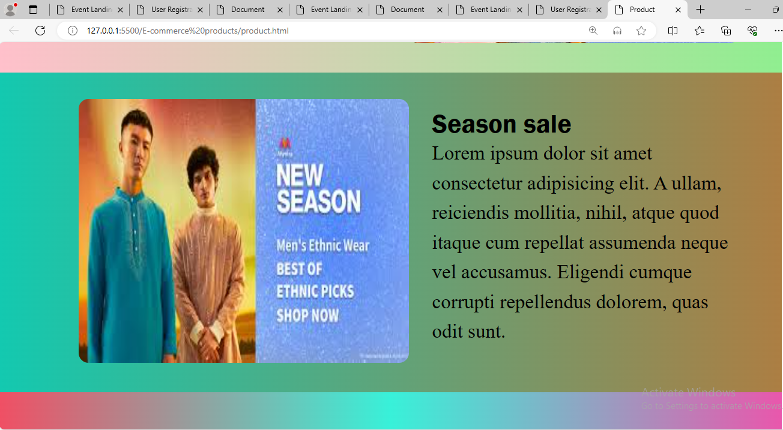

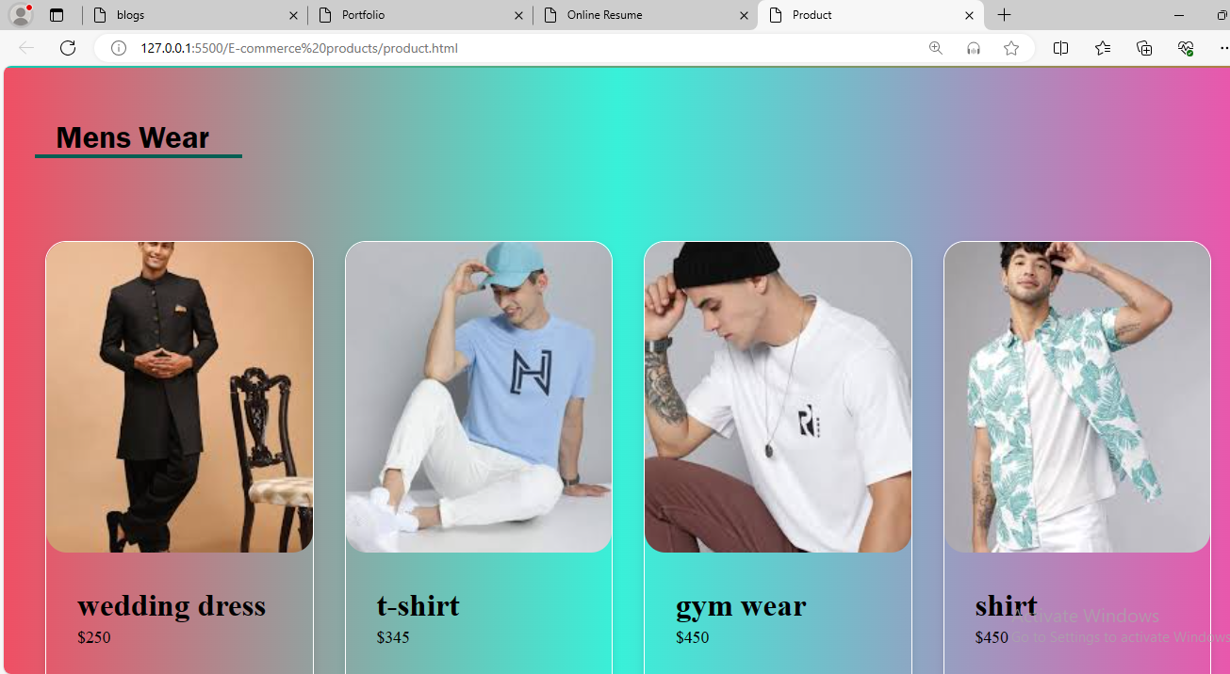

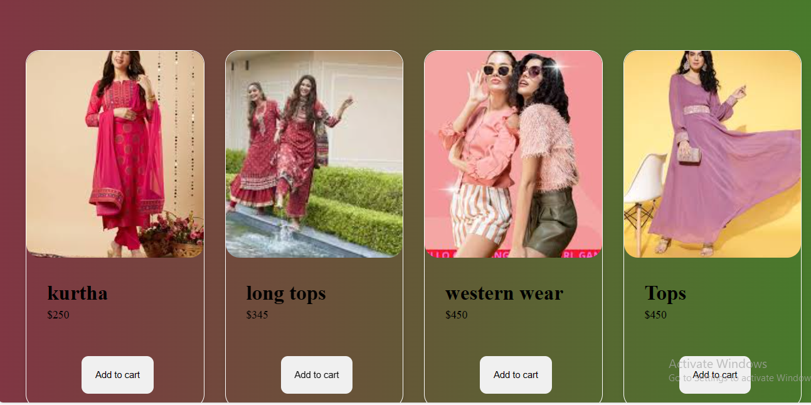

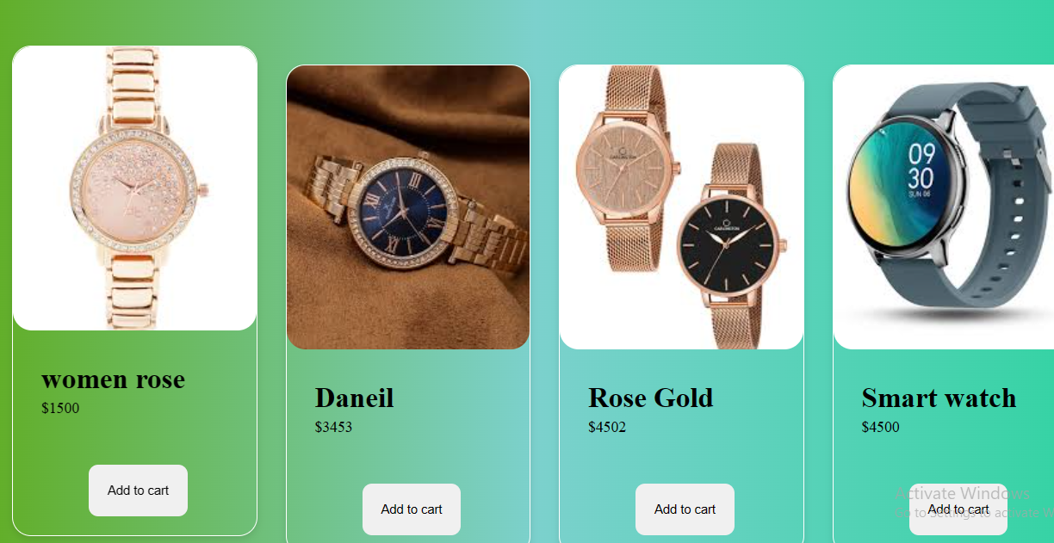

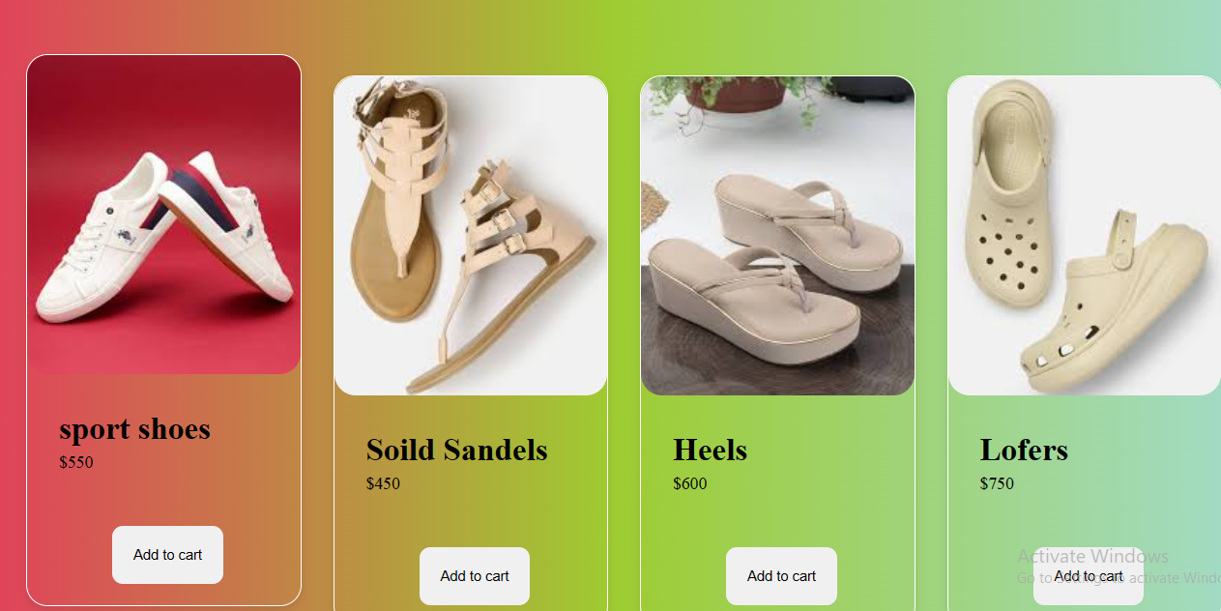

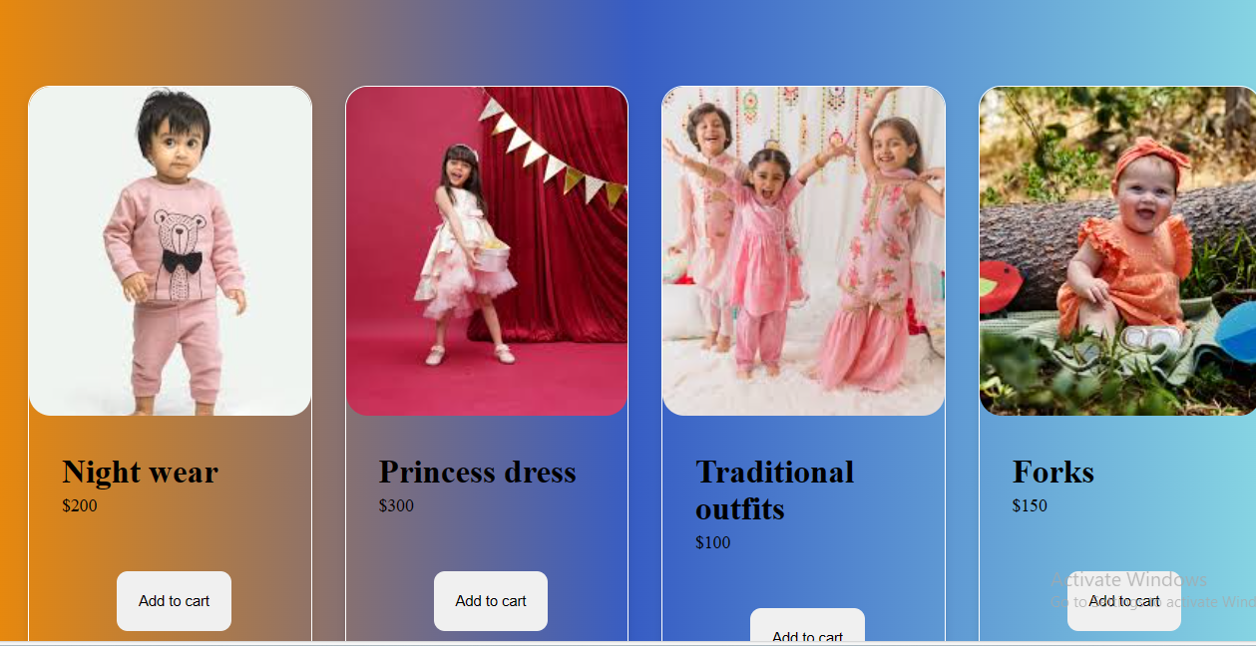

Use Case 12: Event Registration Landing Page

Description:

Create a landing page for an upcoming event, such as a conference or workshop. The page should provide information about the event, including date, location, agenda, and registration details. Design the page layout using HTML and CSS, and consider using CSS animations or transitions to enhance user engagement. Include a registration form for attendees to sign up for the event.

**Code:**

**Html:**

<!DOCTYPE html>

<html lang="en">

<head>

    <meta charset="UTF-8">

    <meta name="viewport" content="width=device-width, initial-scale=1.0">

    <title> Event Landing</title>

    <link rel="stylesheet" href="event.css">

</head>

<body>

    <div class="total-page">

        <div class="myntra">

            <div class="mytra-product">

                <div class="products"><img src="images/events.jpg" alt="image" width="88px" height="88px"></div>

            </div>

            <div class="Contact">

                <a href="">Home</a>

                <a href="">About</a>

                <a href="">Contact Us</a>

            </div>

        </div>

    </div>

    <div class="info">

        <div class="categories">

            <a href="">Mehandi event</a>

            <a href="">Haldi event</a>

            <a href="">Wedding day</a>

        </div>

    </div>

    <div class="sale">

        <div class="sale-offer">

            <div class="season">

                <h1>Mehandi Event</h1>

               <p><span>title</span>mehandi</p>

               <p><span>timings</span>11:am to 2pm</p>

               <p><span>location</span>Hyderabad gardens</p>

            </div>

            <div class="image">

                <img src="images/mehandi1.webp" alt="image">

            </div>

        </div>

    </div>

    <div class="sale1">

        <div class="sale-offer">

            <div class="season">

                <h1>Haldi Event</h1>

                <p><span>title</span>Haldi</p>

                <p><span>timings</span>11:am to 2pm</p>

                <p><span>location</span>Hyderabad gardens</p>

            </div>

            <div class="image">

                <img src="images/haldi1.webp" alt="image">

            </div>

        </div>

    </div>

    <div class="sale doc">

        <div class="sale-offer">

            <div class="image">

                <img src="images/wedding2.jpg" alt="image">

            </div>

            <div class="season">

                <h1>Wedding Day</h1>

                <p><span>title</span>Wedding</p>

                <p><span>timings</span>11:am to 2pm</p>

                <p><span>location</span>Hyderabad function hall</p>

            </div>

            </div>

            <div class="total-form">

                <div class="form">

                    <form class="feilds">

                        <div class="name">

                            <label for="name">Name</label>

                            <input type="text" placeholder="type here" id="name" name="name">

                        </div>

                        <div class="name">

                            <label for="email">Email</label>

                            <input type="email" placeholder="type here" id="email" name="email">

                        </div>

                        <div class="message">

                            <label for="message">Message</label>

                            <textarea name="message" id="message"></textarea>

                        </div>

                        <div class="submit">

                            <input type="submit" value="Contact me">

                        </div>

                    </form>

                </div>

            </div>

            <footer>

                <div class="base">

                    <div class="right">

                        <h4>@copy rights 2024 by:Sharvani reddy</h4>

                    </div>

                </div>

            </footer>

</body>

</html>

**Css:**

*{

    margin: 0px;

    padding: 0px;

    box-sizing:border-box;

}

.total-page{

    background: radial-gradient(#fff,rgb(150, 226, 135));

    height: 100%;

}

.myntra{

    display: flex;

    justify-content: space-between;

    align-items: center;

    padding: 10px 20px;

}

.products img{

    border-radius: 50%;

    box-shadow: 0 0 5px rgba(0,0, 0, 0.5);

    animation: 0.9s circle linear infinite;

}

@keyframes circle{

    from{

        transform: rotate(0deg);

    }

    to{

        transform: rotate(360deg);

    }

}

.Contact a{

    margin-left: 20px;

    margin-right: 20px;

    text-decoration: none;

    font-size: 20px;

    font-weight: bold;

    font-family: 'Segoe UI', Tahoma, Geneva, Verdana, sans-serif;

}

.categories a{

    text-decoration: none;

    margin-left: 20px;

    margin-right: 20px;

    text-decoration: none;

    font-size: 30px;

    font-weight: bold;

    font-family: 'Segoe UI', Tahoma, Geneva, Verdana, sans-serif;

    margin-top: 80px;

    margin-bottom: 80px;

    padding: 20px;

    border: 1px solid #fff;

    background-color: aquamarine;

    border-radius: 20px;

    color: rgb(241, 87, 151);

    transition: transform 0.6secs;

}

.info{

    background: radial-gradient(#fff,rgb(199, 212, 206));

    height: 100%;

}

.categories{

    display:flex;

    align-items: center;

    justify-content: center;

}

.categories a:hover{

    transform:translateY(-10px);

}

.sale{

    background:linear-gradient(90deg,rgb(53, 175, 70),rgb(72, 141, 72))

}

.sale-offer{

    display: flex;

}

.season{

    margin-top: 40px;

    padding: 15px;

    margin-left: 20px;

}

.season p span{

    color: rgb(0, 255, 179);

}

.season p span::after{

    content: ":";

}

.season h1{

    font-size:40px;

    font-weight: bold;

    font-family: 'Franklin Gothic Medium', 'Arial Narrow', Arial, sans-serif;

}

.season p{

width: 450px;

line-height: 1.5;

font-size: 30px;

}

.image img{

    margin-left: 120px;

    width: 500px;

    height: 400px;

    border-radius: 15px;

    margin-top: 40px;

    margin-bottom: 40px;

}

.doc{

    background:linear-gradient(90deg,rgb(197, 9, 9),#f85454)

}

.total-form{

    display: flex;

    justify-content: center;

    align-items: center;

    height: 100vh;

    background: linear-gradient(90deg,pink,rgb(124, 236, 124));

background-image: url(images/background.avif);

}

.feilds{

    border: 2px solid black;

    padding: 80px;

    border-radius: 10px;

}

.name input{

    border: 1px solid wheat;

    border-radius: 10px;

    padding: 10px;

    margin: 5px;

    width: 100%;

}

.message textarea{

    border: 1px solid wheat;

    border-radius: 10px;

    padding: 20px;

    width: 100%;

}

.submit input{

    width: 100%;

    padding: 10px;

    border-radius: 20px;

    margin-top: 10px;

    cursor: pointer;

}

footer{

    background-color: #555;

    height: 50px;

    padding: 15px;

}

.right h4{

    margin-top: 10px;

    text-align: center;

    margin-bottom: 10px;

    color: aliceblue;

}

.sale1{

    background:linear-gradient(90deg,rgb(255, 245, 103),rgb(241, 238, 60))

}

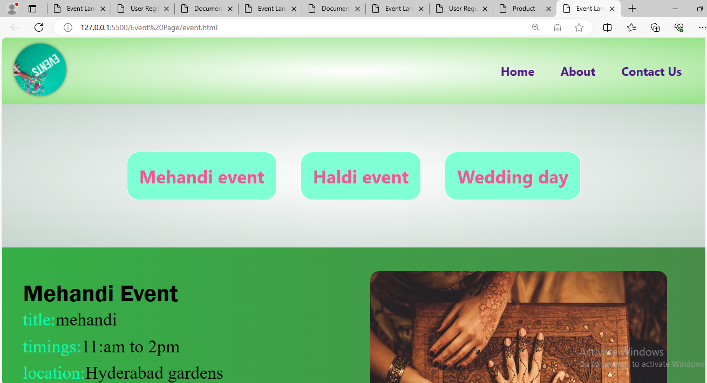

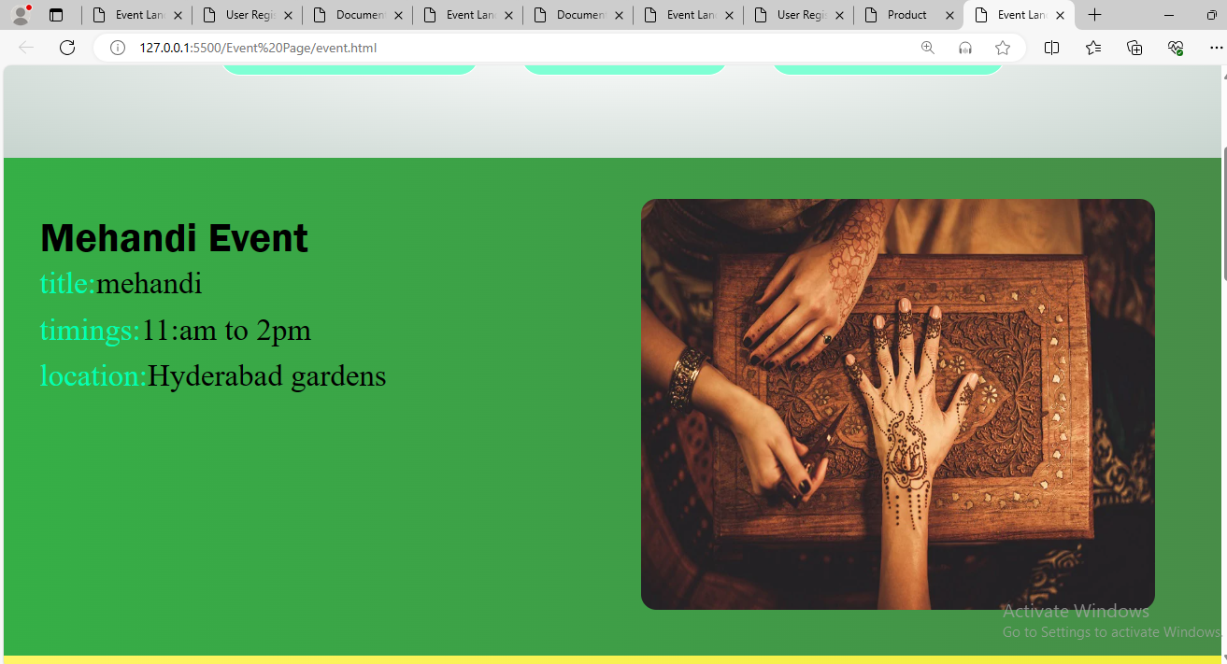

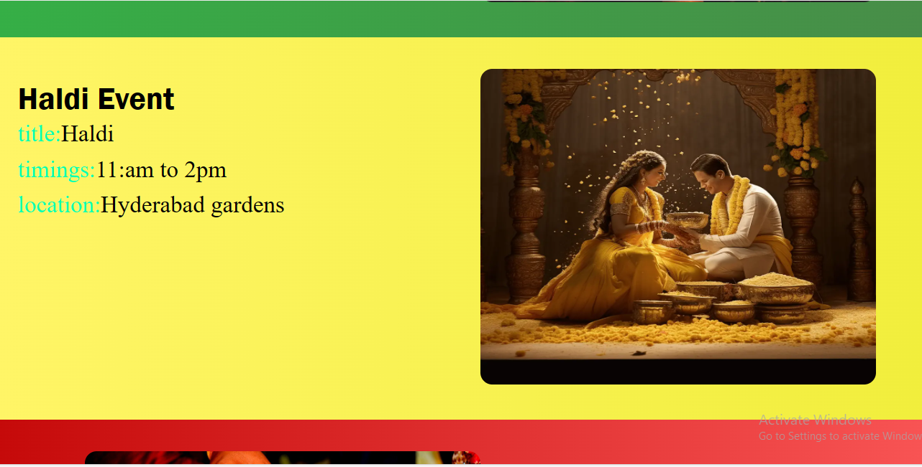

Use Case 13: Portfolio Website

Description:

Design and develop a personal portfolio website to showcase your projects, skills, and experience. The website should include sections for an about me, portfolio projects with descriptions and images, skills, and contact information. Use HTML to structure the content and CSS to style the layout and appearance of the website. Ensure the website is responsive and accessible on different devices.

**Code:**

**Html:**

<!DOCTYPE html>

<html lang="en">

<head>

    <meta charset="UTF-8">

    <meta name="viewport" content="width=device-width, initial-scale=1.0">

    <title>Portfolio</title>

    <link rel="stylesheet" href="portfolio.css">

</head>

<body>

    <header class="header">

        <a href="" class="logo"><span>Sharvani</span></a>

        <nav class="navbar">

            <a href="" class="active">Portfolio</a>

            <a href="">Services</a>

            <a href="">Experience</a>

            <a href="">Projects</a>

            <a href="">Education</a>

        </nav>

        <a href="#" class="contact">Contact Me</a>

    </header>

    <section class="home">

        <div class="home-content">

            <h3>Hi</h3>

            <h1>I'm <span>Sharvani.P<br></span> a Frontend Developer</h1>

            <p>Lorem, ipsum dolor sit amet consectetur adipisicing elit. Laudantium voluptates accusantium nostrum aspernatur veniam deleniti minus fugiat, at voluptatibus ullam, recusandae nesciunt iste inventore obcaecati eos modi. Ratione, repudiandae praesentium?</p>

            <div class="btn-box">

                <button class="btn-1">Hire Me</button>

                <button class="btn-2">Experience</button>

            </div>

        </div>

        <div class="img-box">

            <img src="images/image1.jpg" alt="image">

        </div>

    </section>

    <section class="about">

        <div class="about-image">

            <img src="images/image1.jpg" alt="image">

        </div>

        <div class="about-content">

            <h2 class="heading">About <span>Me</span></h2>

            <h3>Frontend <span>Developer</span></h3>

            <p>Lorem ipsum dolor sit amet consectetur adipisicing elit. Veniam nulla porro quasi, animi laborum repudiandae quae neque. Labore rerum minima itaque sit voluptate quia obcaecati cumque, quibusdam voluptates quod id!Lorem</p>

            <a href="" class="btn-2">Experience</a>

        </div>

    </section>

    <section class="contact-form">

        <h2 class="contact-me">Contact <span>Me</span></h2>

        <form>

            <div class="input-box">

               <input type="text" placeholder="full name" required>

               <input type="email" placeholder="email" required>

            </div>

            <div class="input-box">

                <input type="number" placeholder="Phone Number" required>

                <input type="text" placeholder="Subject" required>

             </div>

             <textarea name="" id="" cols="30" rows="10" placeholder="Your Message" required></textarea>

             <input type="submit" value="Send Message" class="btn-1">

        </form>

    </section>

    <footer class="footer">

        <ul class="list">

            <li>

                <a href="">FAQ</a>

            </li>

            <li>

                <a href="">Services</a>

            </li>

            <li>

                <a href="">About Me</a>

            </li>

            <li>

                <a href="">Contact</a>

            </li>

            <li>

                <a href="">Privacy Policy</a>

            </li>

        </ul>

        <p class="copyright">@2024 by:Sharvani.P</p>

    </footer>

</body>

</html>

**Css:**

*{

    margin: 0px;

    padding: 0px;

    box-sizing: border-box;

}

.header{

    position: fixed;

    width: 100%;

    padding: 35px 12%;

    background: black;

    backdrop-filter: blur(10px);

    display: flex;

    justify-content: space-between;

    align-items: center;

    z-index: 100;

}

.logo{

    font-size: 25px;

    color: white;font-weight: 600;

    transition: 0.3 ease;

    text-decoration: none;

}

.logo:hover{

    color: orangered;

    text-shadow: 0 0 30px orangered;

    transform: scale(1.1);

}

span{

    color:orangered;

}

.navbar a{

    font-size: 18px;

    color:antiquewhite;

    font-weight: 500;

    margin: 0 20px;

    border-bottom: 3px solid transparent;

    transition: 0.3s ease;

    text-decoration: none;

}

.navbar a:hover,

.navbar a.active{

    color: orangered;

    border-bottom: 3px solid orangered;

}

.contact{

    padding: 10px 28px;

    background-color: white;

    color: black;

    border: 2px solid transparent;

    border-radius: 8px;

    font-size: 16px;

    letter-spacing: 1px;

    font-weight: 600;

    transition: 0.3s ease;

    text-decoration: none;

}

.contact:hover{

    background-color: orangered;

    box-shadow: 0 0 25px orangered;

    color: white;

}

.home{

    width: 100%;

    min-height: 100vh;

    background: rgb(241,241,241);

    display: flex;

    align-items: center;

    gap: 7em;

    padding: 30px 12% 0;

}

.home-content{

    max-width: 800px;

}

.home-content h3{

    font-size: 42px;

}

.home-content h1{

    font-size: 62px;

    line-height: 1.2;

}

.home-content p{

    font-size: 18px;

    margin: 25px 0 30px;

}

.btn.box{

    width:345px;

    display: flex;

    gap: 2em;

}

.btn-1{

    padding: 15px 20px;

    background-color: black;

    color: white;

    border-radius: 8px;

    font-size: 18px;

    letter-spacing: 1px;

    font-weight: 600;

    transition: 0.3s ease;

    cursor: pointer;

}

.btn-1:hover{

    background-color: white;

    color: black;

    border: 2px solid black;

}

.btn-2{

    padding: 15px 20px;

    background-color: orangered;

    color: white;

    border: 2px solid black;

    border-radius: 8px;

    font-size: 18px;

    letter-spacing: 1px;

    font-weight: 600;

    transition: 0.3s ease;

    cursor: pointer;

    text-decoration: none;

}

.btn-2:hover{

    background-color: white;

    color: orangered;

}

.img-box img{

    border-radius: 50%;

    width: 550px;

}

.about{

    display: flex;

    justify-content: center;

    align-items: center;

    padding: 12% 18%;

    gap: 10em;

    background: black;

}

.about-image img{

    position: relative;

    width: 550px;

    box-shadow: 0 0 25px orangered;

    border-radius: 50%;

}

.about-content h2{

    text-align: left;

    color: white;

    font-size: 42px;

}

.about-content h3{

    font-size: 62px;

    color: white;

}

.about-content p{

    color: white;

    font-size: 20px;

    margin: 2em 0 3em;

}

.contact-form h2{

    text-align: center;

    margin-top: 3em;

    margin-bottom: 1em;

    font-size: 36px;

}

.contact-form form{

    max-width: 50em;

    margin: 1rem auto;

    text-align: center;

    margin-bottom: 3em;

}

.contact-form form .input-box input,

.contact-form form textarea{

    width: 100%;

    padding: 1.5em;

    font-size: 18px;

    color: black;

    background: rgb(241,241,241);

    border-radius: .8rem;

    margin: 1rem 0;

    resize: none;

}

.footer{

    position: relative;

    bottom: 0;

    width: 100%;

    padding: 40px 0;

    background-color: black;

}

.footer ul{

    margin-top: 0;

    padding: 0;

    font-size: 18px;

    line-height: 1.6;

    margin-bottom: 0;

    text-align: center;

}

.footer ul li a{

    color: white;

    border-bottom: 3px solid transparent;

    transition: 0.3s ease;

    text-decoration: none;

}

.footer ul li a:hover{

    border-bottom: 3px solid orangered;

}

.footer ul li{

    display: inline-block;

    padding: 0 15px;

}

.footer .copyright{

    margin-top: 15px;

    text-align: center;

    font-size: 12px;

    color: white;

}

**Output:**

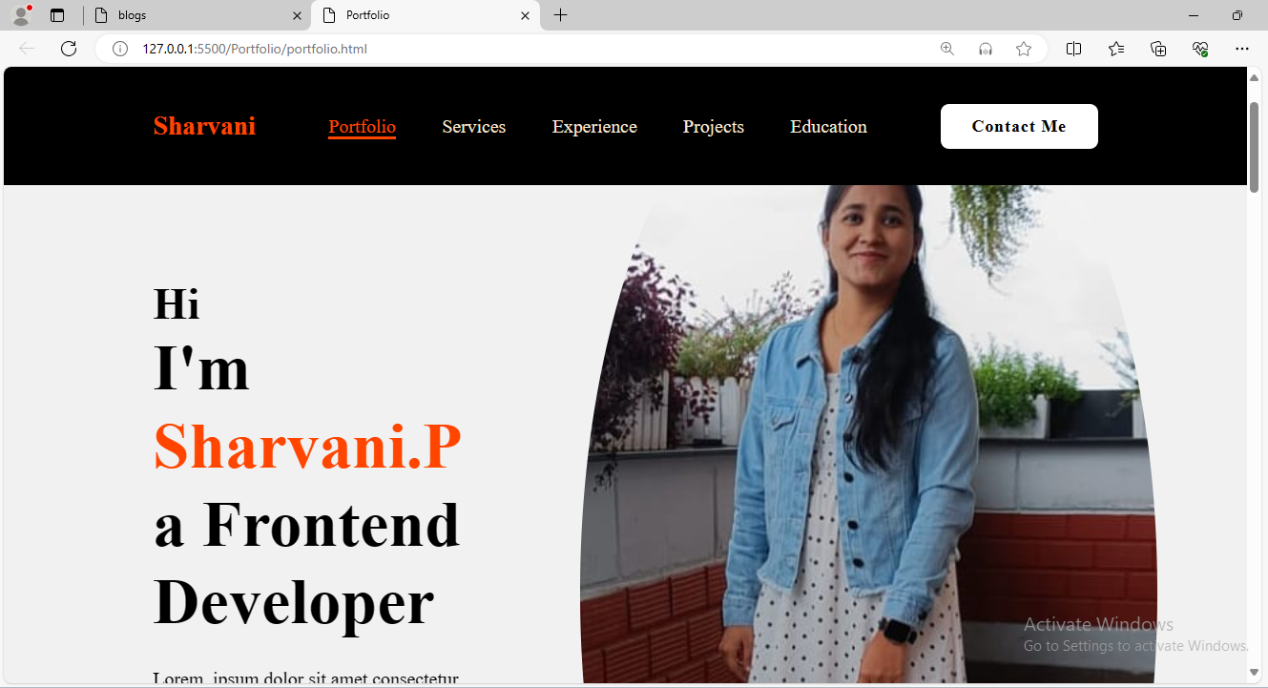

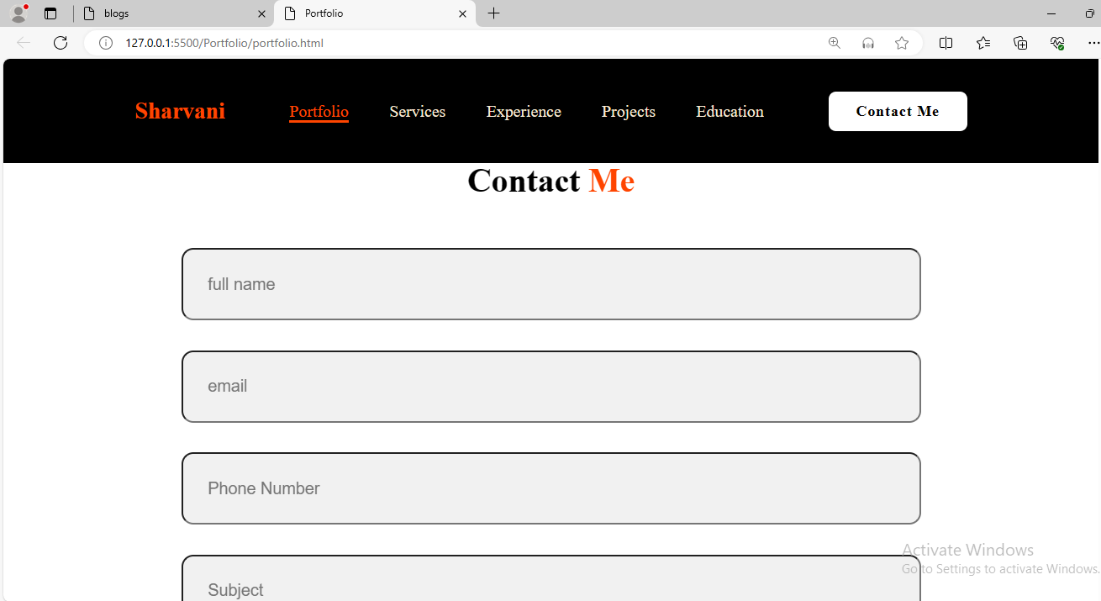

Use Case 14: Blog Website

Description:

Build a static blog website where users can read and interact with blog posts on various topics. Each blog post should include a title, author, publication date, content, and comments section. Design the layout of the blog website using HTML and CSS, and consider incorporating CSS grid or flexbox for the post listing and layout. Include navigation links to allow users to browse through different blog categories.

**Code:**

**Html:**

<!DOCTYPE html>

<html lang="en">

<head>

    <meta charset="UTF-8">

    <meta name="viewport" content="width=device-width, initial-scale=1.0">

    <title>blogs </title>

    <link rel="stylesheet" href="blog.css">

</head>

<body>

    <div class="total-page">

        <div class="blog">

            <h2>Blog title</h2>

        </div>

        <div class="navblog">

            <nav>

                <a href="">Home</a>

                <a href="">About</a>

                <a href="">Books</a>

                <a href="">Contact</a>

            </nav>

        </div>

    </div>

    <div class="navclass">

        <div class="navq">

            <div class="about">

                <div class="home">

                    <ul>

                        <li><a href="">Home</a></li>

                        <li><a href="">About</a></li>

                        <li><a href="">Books</a></li>

                        <li><a href="">Contact</a></li>

                    </ul>

                </div>

            </div>

        </div>

        <div class="high">

            <div class="book-details">

                <img src="images/image1.jpeg" alt="image" />

                <div class="content-area">

                  <p><span>Title:</span>The God of small Things</p>

                  <p><span> published:</span> 1997</p>

                  <p><span>Authors:</span>Arundhati Roy</p>

                  <p>

                    <span>Description:</span>The God of Small Things is a family drama novel written by Indian writer Arundhati Roy. It is a story about the childhood experiences of fraternal twins whose lives are destroyed by the "Love Laws" prevalent in 1960s Kerala, India. The novel explores how small, seemingly insignificant occurrences, decisions and experiences shape people's behavior in deeply significant ways. The novel also explores the lingering effects of casteism in India, lending a culturally-specific critique of British colonialism in India. It won the Booker Prize in 1997..

                  </p>

                </div>

              </div>

              <div class="book-details">

                <img src="images/images2.jpeg" alt="image" />

                <div class="content-area">

                  <p><span>Title:</span>The Inheritance of Loss</p>

                  <p><span> published:</span> 2006</p>

                  <p><span>Authors:</span>Kiran Desai</p>

                  <p>

                    <span>Description:</span>The story centres around the lives of Biju and Sai. Biju is an Indian living in the United States illegally, son of a cook who works for Sai's grandfather. Sai is an orphan living in mountainous Kalimpong with her maternal grandfather Jemubhai Patel, the cook, and a dog named Mutt. Her mother was a Gujarati and her father a Zoroastrian orphan himself.[4] Author Desai alternates the narration between these two points of view. The action of the novel takes place in 1986.

                  </p>

                </div>

              </div>

              <div class="book-details">

                <img src="images/image3.jpg" alt="image" />

                <div class="content-area">

                  <p><span>Title:</span>The Guide</p>

                  <p><span> published:</span>1958</p>

                  <p><span>Authors:</span>R. K. Narayan</p>

                  <p>

                    <span>Description:</span>The protagonist, Raju, who is nicknamed "Railway Raju", is characterized as being a corrupt and popular tour guide. In the story, he falls in love with a beautiful woman named Rosie, who is married to an archaeologist named Marco, while the couple is visiting Malgudi as tourists. Marco disapproves of Rosie's passion for dancing but Raju encourages Rosie to pursue her dreams and become a dancer. With this interaction, they begin to spend time with each other and become very close.

                </div>

              </div>

        </div>

</body>

</html>

**Css:**

*{

    margin: 0px;

    padding: 0px;

    box-sizing: border-box;

}

.total-page{

    display: flex;

   justify-content: center;

    align-items: center;

    background-color: lightcoral;

    padding:30px;

}

.blog h2{

    font-family: 'Courier New', Courier, monospace;

    font-size: 30px;

    font-weight: bold;

    margin-top: 30px;

    margin-right: 250px;

}

nav a{

    text-decoration: none;

    margin-right: 40px;

    border: 2px solid white;

    border-radius: 10px;

    padding: 15px;

    box-shadow: 0 0 5px rgba(0,0,0,0.5);

    margin-top: 20px;

}

nav a:hover{

    background-color: #fff;

    color: black;

}

.navclass{

    display: flex;

    width: 100%;

}

.navq{

    width: 20%;

    background-color:lightskyblue;

    height: 100vh;

}

.home ul li{

    padding: 15px;

    margin-top: 20px;

}

.about{

    margin-top: 60px;

}

ul li a{

    text-decoration: none;

}

ul li a:hover{

    color: rgb(255, 255, 255);

    text-shadow:0 0 5px rgba(0,0,0,0.5) ;

}

.high{

    background-color: #fff;

    width: 80%;

   height: 100vh;

   display: grid;

  grid-template-columns: repeat(3, 1fr);

  grid-gap: 10px;

  grid-column-gap: 10px;

}

.book-details {

    border: 4px solid#e1dbdb;

    border-radius: 10px;

    transition: 0.3s;

  }

  .book-details:hover {

    border: 2px solid rgb(222, 9, 6);

    transform: translateY(-20px);

  }

  .book-details img {

    width: 100%;

    object-fit: cover;

    border-top-left-radius: 5px;

    border-top-right-radius: 5px;

  }

  .content-area span {

    margin: 10px;

    font-family: "Lucida Sans", "Lucida Sans Regular", "Lucida Grande",

      "Lucida Sans Unicode", Geneva, Verdana, sans-serif;

    font-size: 18px;

    color: #141414;

    font-weight: 600;

  }

  .content-area p {

    font-size: 15px;

    color: #555;

  }

**Output:**

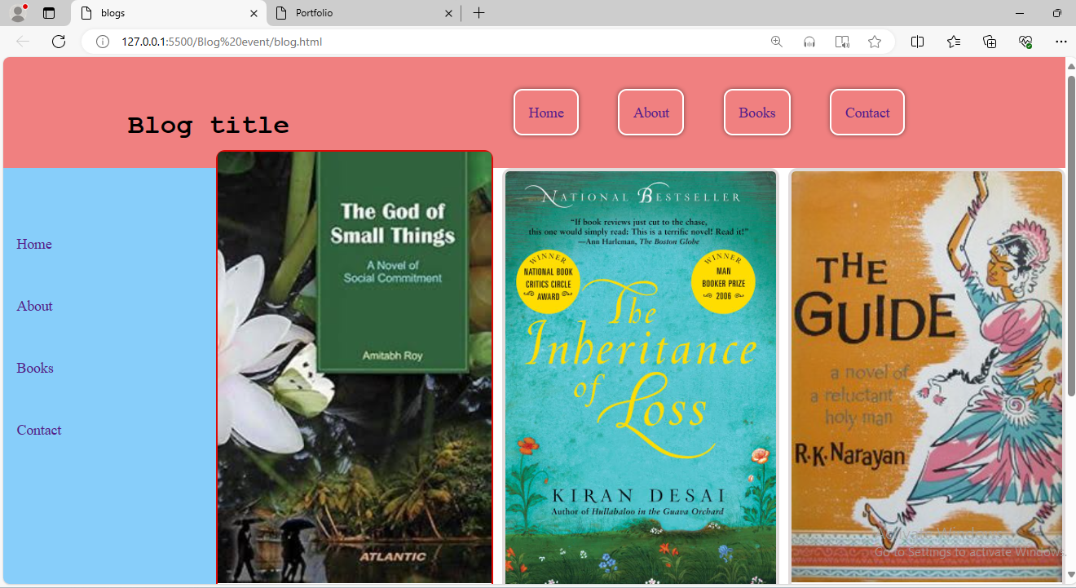

Use Case 15: Online Resume/CV

Description:

Create an online resume or curriculum vitae (CV) using HTML and CSS. The resume/CV should include sections for personal information, education, work experience, skills, projects, and contact details. Design the layout to present information clearly and professionally, using CSS styling to enhance readability and visual appeal. Ensure the resume/CV is responsive and accessible across different devices.

**Code:**

**Html:**

<!DOCTYPE html>

<html lang="en">

<head>

    <meta charset="UTF-8">

    <meta name="viewport" content="width=device-width, initial-scale=1.0">

    <title>Online Resume</title>

    <link rel="stylesheet" href="resume.css">

</head>

<body>

    <div class="total-page">

        <div class="resume">

            <div class="photo">

                <img src="images/image1.jpg" alt="image">

            </div>

            <h1>Sharvani.P</h1>

            <h3>Web Developer</h3>

        </div>

        <div class="main">

            <div class="left">

                <h2>Personal Information</h2>

                <p><strong>Name:</strong>Sharvani.P</p>

                <p><strong>Age:</strong>23</p>

                <p><strong>Email:</strong>sharvanireddy2000@gmail.com</p>

                <p><strong>phone:</strong>7337070131</p>

                <h2>Skills</h2>

                <ul>

                    <li>HTML/CSS</li>

                    <li>Manual Testing</li>

                    <li>Java basics</li>

                </ul>

                <h2>Education</h2>

                <h3>Btech Computer Science</h3>

                <p>JBREC Hyderabad 2018-2022</p><br>

                <h3>Intermediate MPC</h3>

                <p>Suvidya junior college 2016-2018</p><br>

                <h3>SSC</h3>

                <p>Maharshi vidyalaya 2015-2016</p>

            </div>

        </div>

    </div>

</body>

</html>

**Css:**

*{

    margin: 0px;

    padding: 0px;

    box-sizing: border-box;

    font-family: montserrat;

}

body{

    background-color: rgb(125, 246, 255);

}

.total-page{

    background: rgb(252, 246, 246);

    max-width: 800px;

    margin: 60px auto;

    height: 1250px;

    padding: 20px;

    box-shadow: 0 2px 20px rgba(0,0,0,0.3);

}

.resume{

    text-align: center;

}

.resume h1{

    margin-bottom: 10px;

}

.resume{

    text-transform: uppercase;

    font-size: 15px;

    font-weight: 500;

}

.photo{

    width: 200px;

    height: 200px;

    border-radius: 50%;

    overflow: hidden;

    margin: 25px auto;

    border: 15px groove rgb(65, 148, 180);

}

.photo img{

    width: 100%;

}

.main{

    display: flex;

    flex-wrap: wrap;

}

.left{

    flex: 1;

    padding: 30px;

}

.left p{

    line-height: 2;

}

.left ul li{

    line-height: 2;

}

h2{

    background-color: rgb(69, 199, 199);

    padding: 15px;

    color: #fff;

    margin: 30px 0;

    font-size: 20px;

    border-radius: 0 50px 50px 0;

}

@media only screen and (min-width:768px) and (max-width:991px){

    .total-page{

        width: 95%;

        height: auto;

    }

    h2{

        font-size: 18px;

    }

}

@media screen and (max-width:600px){

    .main{

        flex-direction:column;

    }

    .left{

        flex: none;

        width: 100%;

    }

    .total-page{

        width: 95%;

        height: auto;

    }

    h2{

        font-size: 15px;

    }

}

**Output:**



